ShoppyGlobe backend project
ThunderClient screenshots
Running on server
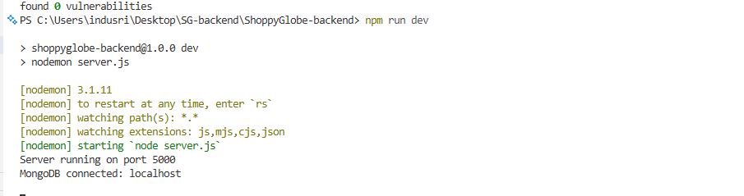

2)Use http://locallost:5000 base.
1)Register (POST /api/auth/register) 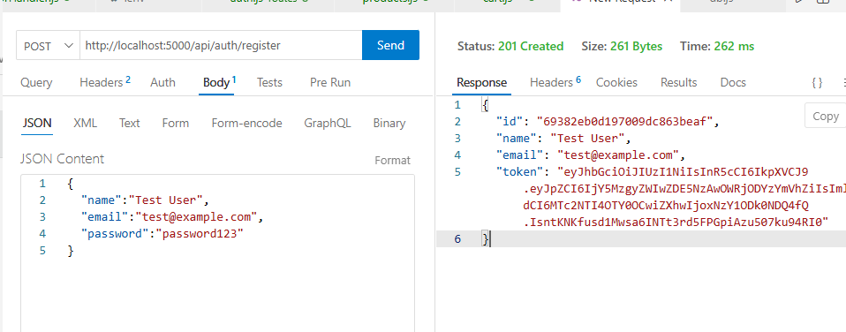
2)Login(POST /api/auth/login
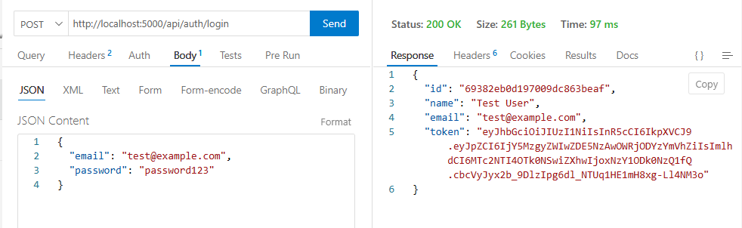
3)Create product(POST /api/products)—for seeding
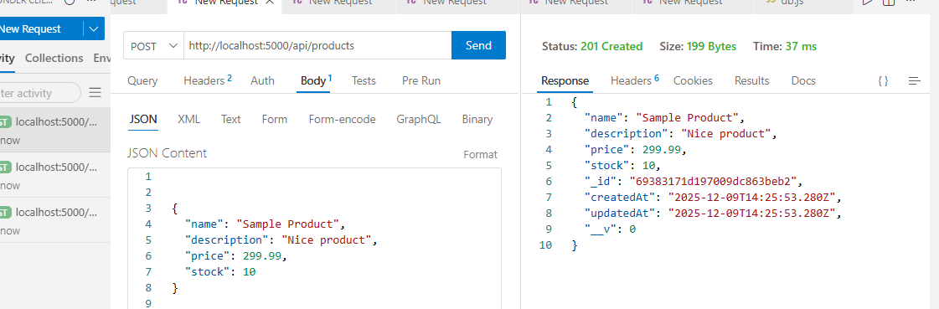
4) List products (GET /api/products)

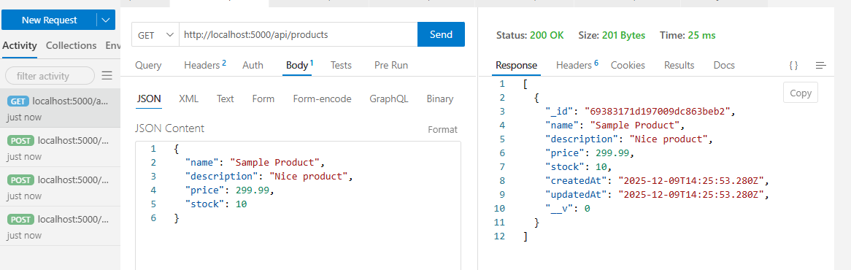

5) Get product (GET /api/products/:id)
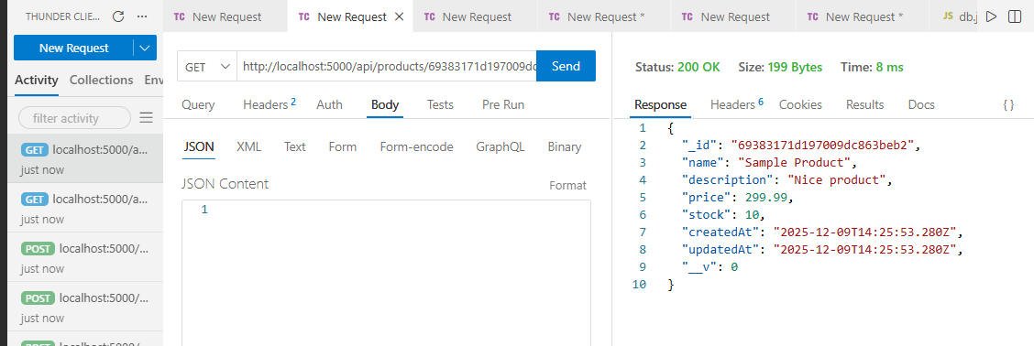
6) Add to cart (POST /api/cart) — protected
Headers: Authorization: Bearer <token>
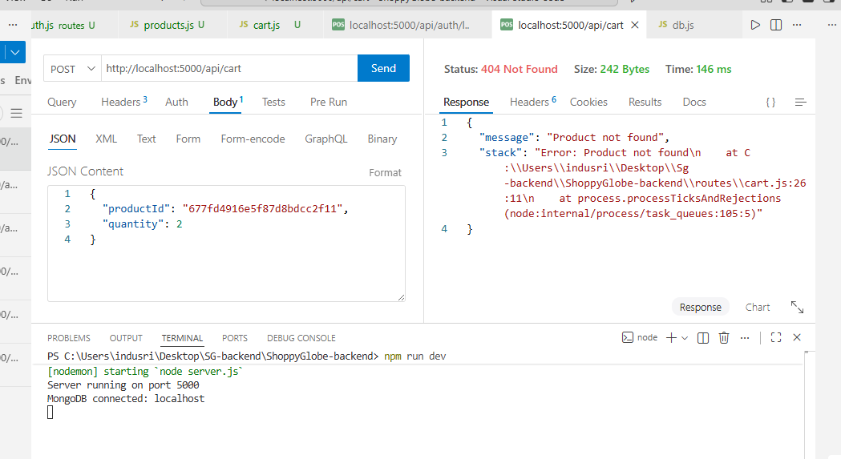
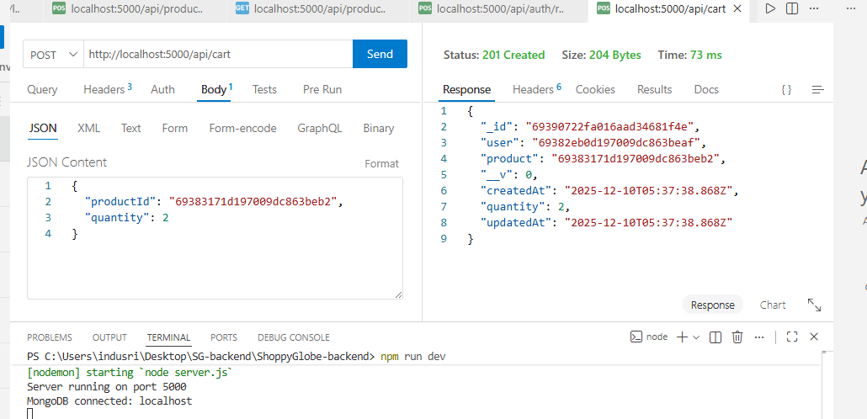

Update cart item (PUT /api/cart/:cartItemId) — protected
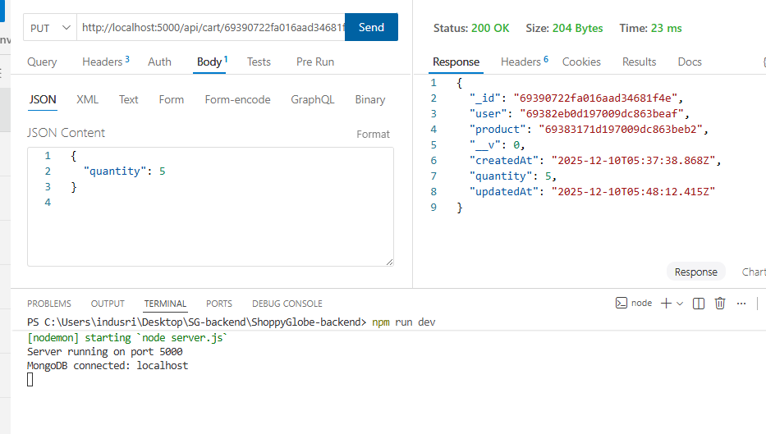
Delete cart item (PUT /api/cart/:cartItemId) — protected

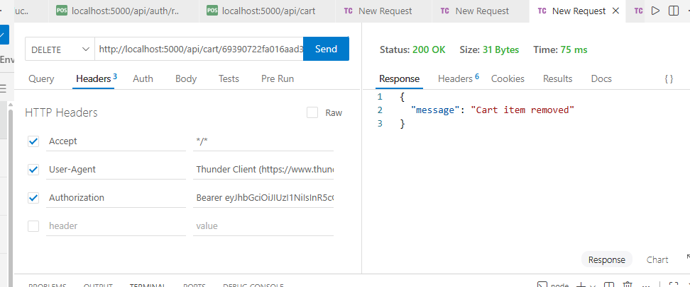

MongoDB Screenshots
1. Open MongoDB Compass
- Run MongoDB Compass from your Start Menu.
- Connect using:
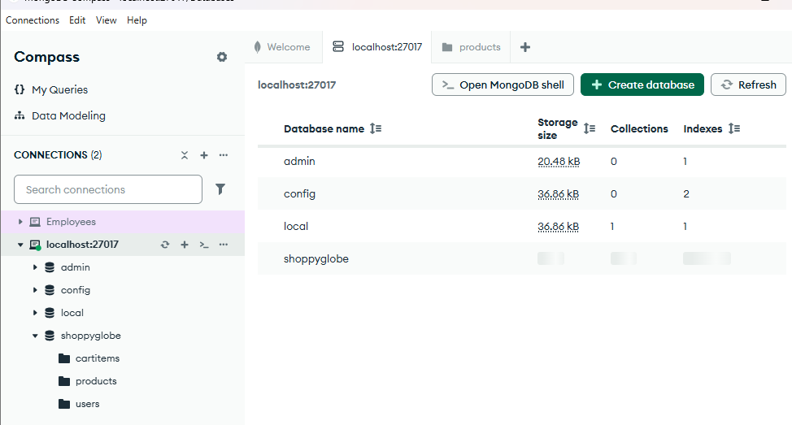
2. Open Your Database
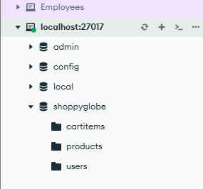
3) Screenshot 1 — Products Collection
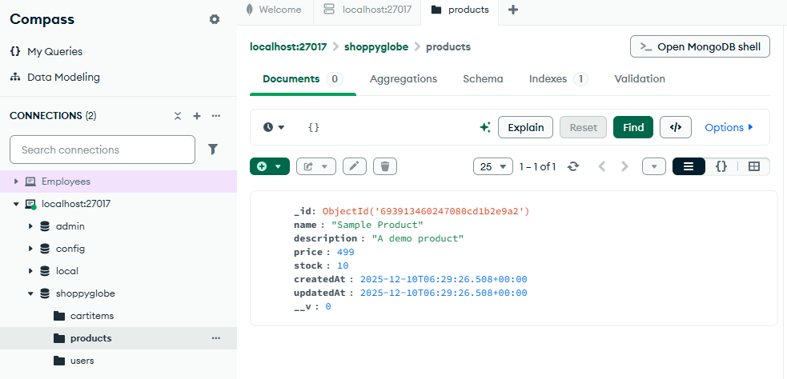
4)Added username
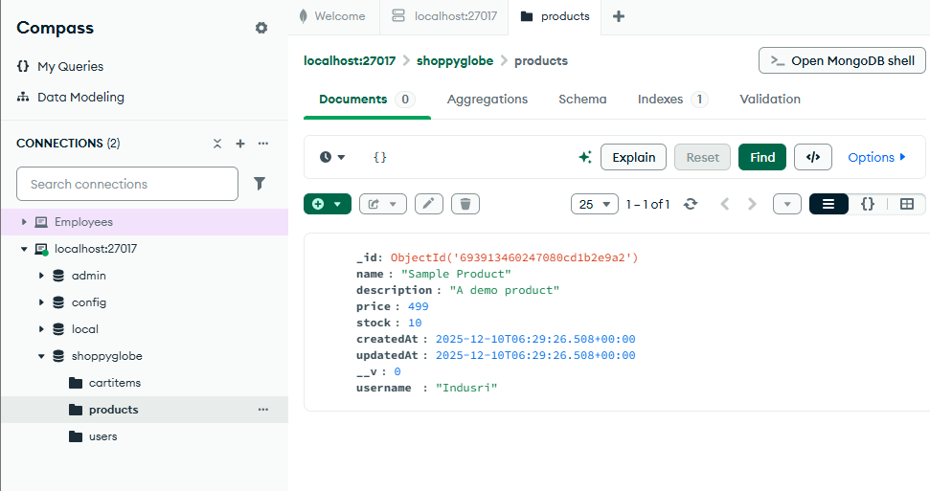
Step 1 — Create a User using Thunder Client / Postman
Send a POST request:
POST
http://localhost:5000/api/auth/register
Body (JSON)
{
"name": "Test User",
"email": "test@gmail.com",
"password": "123456"
}
